**TITLE OF PROJECT**

**Recipe Maker using Android Studio**

**A Project Work Synopsis**

*Submitted in the partial fulfillment for the award of the degree of*

**BACHELOR OF ENGINEERING (B.E)**

**IN**

**CSE(AI and ML)**

**Submitted by:**

**SHAWAL KUMAR(GL)**

**UID - 18BCS6066**

**AMANPREET KAUR**

**UID - 18BCS6038**

**DIVYAM SRIVASTAVA**

**UID - 18BCS6057**

**SATYAM VIBHU**

**UID - 18BCS6053**

**VAIBHAV TRIPATHI**

**UID - 18BCS6052**

**Under the Supervision of:**

**MANDEEP TINNA SIR**



**CHANDIGARH UNIVERSITY, GHARUAN, MOHALI - 140413,**

**PUNJAB**

**MONTH & YEAR**

***Annexure-4* (A typical specimen of table of contents)**

**Table of Contents**

Title Page

**Recipe Maker using Android Studio**

**Abstract**

There are many applications in the Android Search Recipes Store but they do not exist support interface for searching, saving, and sharing recipes Instant Cooking is android application with UI based on image search, sharing, creation and storage recipes. This app provides flexible user search for top rated and variety of recipes from recipes available in the cloud. This is an excellent app, which every user can search for cloud cooking, save recipe as favorite, share recipe with friends on social media Facebook, Twitter, Google+ and Gmail and create a personalized cookbook. This app is time a repository that provides recipes with a few clicks. By combining ingredients and article search, Quick Eaten app makes finding recipes easy. With recipes added daily will always be something new that the user longs for. The project was created using Java, Android and SQLite. The Food2Fork API has been deprecated to find recipes from the cloud.

1. INTRODUCTION

**QuickRecipes** app is a very useful app for people who like to cook and try new things recipes. **The QuickRecipes** application provides user flexibility to search, share, save recipes from the cloud with the extra power to keep a personal cookbook for new construction recipe, removes unnecessary recipe.

My application **"QuickRecipes"** makes finding recipes easier. Cooking comes every day chefs and cooks who complete the recipe over time. The Food2Fork API is used for search recipes from the cloud. Cooking from decadent to the simplicity of anything mood user in. With recipes added daily to the Food2Fork database it will always be something new that the user can try. Cooking from well-known publishers All Recipes, 101 cookbooks, Closet Cooking and many more. The **QuickRecipes** application provides the ability of the user to search for balanced, advanced recipes. Recipes are indicated by recipe photo, title, list of ingredients and recipes. The category is based on based ingredients search is also provided by the user. The **QuickRecipes** App provides sharing power, providing the user opting to share the recipe via Facebook, Twitter, Google+ and Gmail. This is the app is a time saver that provides recipes with a few clicks. The user is given the opportunity to create their own a cookbook, where the user can create a recipe, view the recipe and delete the recipe. The interface is clean and easy. It uses the power of the Android image button to display options on home screen with image icons. User can research recipes, see a list of additional favorites and access a personal cookbook all from the home screen.

* 1. **Problem definition**

In the age of technological advancement, it is simply impossible to imagine a process of relaxation or work without the use of gadgets. Thanks to mobile devices, users can, at any time, no matter where they are, can perform a variety of tasks using the World Wide Web. Internet applications are designed in such a way that they give the user easy access to the things needed to build a business or other tools that can be used in daily life.

Stable internet stability, versatility and ease of use - these are ways to attract even the most selective users of iOS or Android devices. Custom applications are often designed to meet the expectations of users of different ages. The program is simple, easily accessible to children or novice just beginning to understand certain features of their gadgets.

The interface plays an important role here. Every day, mobile app developers participate in improving their products. This helps not only to increase the quality and smoothness of the system, but also allows for increased competition in the modern technology market. The balance between quality and product cost creates a major demand in the market.

**1.2Project Overview/Specifications**

The purpose of this step is to ensure that the requirements are the same, and more precise completed to ensure we meet the final results we expect. There are two types of needs: functional and non-functional needs. Operational requirementsthey define the functions of the application; whereas, which does not workrequirements are what present the application and architectural issues.

1. **External Connector Requirements:**

* **Hardware:**The mobile app will be running on Android apps.
* **Software:**The mobile app will be compatible with both mobile and desktop(Android app) the latest versions.
* **Communication:**The app will be dynamic. It will work with users instantlyaccording to the receipt it receives.
* **Users:**Users will need to enter their details such as name, address andphone to be recorded in the database and log in to access moreSpecific functionality such as Create / View / Delete / Search Recipe. Also,if they want to keep a shopping list (necessary ingredients). Thesedetails will be stored in our database.

1. **Operational requirements:**

* **Register**: The user needs to register to access the app. User needs loginhis username, password, age, and country. That information will be stored indatabase will also serve as profile information.
* **Login:** Any application performance requires the user to be registered. Signing in is the first stepbefore taking action.
* **View profile:** After successful registration. The user can view his profile,where username details, age and country are displayed. Also, View profilewill help you look at your recipes and recipes that you have marked asfavorite. Additionally, View Profile will let you check your shopping list to findnecessary ingredients.
* **Edit Profile:** The registered user will be able to edit his profile, such as editingusername and other information. Also, you will be able to reset the password ifit is necessary.
* **View recipe:** The registered user will be able to see recipes posted by other users.In other words, the user will be able to access the Recipe Forum, where every userrecipes are shipped and ordered on the day of creation.
* **Create a recipe:** Any registered user will be able to create their own recipe. Themaking of the recipe includes including title, description, and other information as wellaffects the recipe, such as steps and ingredients.
* **Search recipe:** Any registered user will be able to search for a recipe usingtopic as a goal. Search functionality will provide users with a shortcut tofind out their intended methods if previously posted by users.
* **Enter the recipe as favorites:** When the user has access to the recipe information, it will be yoursable to mark the recipe as a favorite.
* **View Ingredients:** The registered user of the app will be able to view the ingredients forspecific recipe. This option will allow you tomark those ingredients as needed,and finally find them on the shopping list.
* **View my recipes:** The registered user will be able to see all the recipes they already havecreated.
* **Delete recipe:** The registered user will be able to delete his recipes, himself already posted.
* **View My Shopping List:** The registered user will be able to manage their purchasesa list based on the required ingredients.
* **Remove the ingredient:** The user will be able to remove the ingredients from the storeslist, if purchase was made or for other reasons.
* **Look at my favorite recipes:** The user will have access to the recipes he usesmarked as a favorite.
* **Plan a meal:** The user will be able to plan a meal / create events.
* **View My Scheduled Events:** User will be able to see the list of events, himselfit's already created.
* **Follow / Stop Tracking:** The user will be able to track the user. The next feature will doallow users to continue posting about recipes posted by their subsequent users. Similarity another recipe forum, but in this case, it is specifically designed to list recipes posted by users followed by user. In addition, the user will be able to "follow" a particular user if necessary, as a result, that user will be downgraded "Following".

1. **Use Case Diagram:**

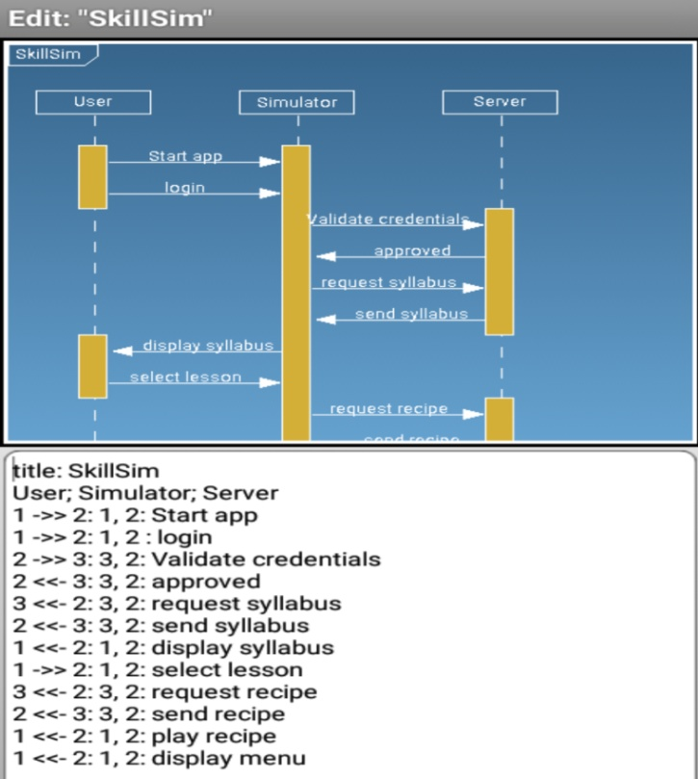

* 1. **Hardware Specification**

An Android Virtual Device (AVD) is a configuration that defines the characteristics of an Android phone, tablet, Wear OS, Android TV, or Automotive OS device that you want to simulate in the  Android Emulator . The AVD Manager is an interface you can launch from Android Studio that helps you create and manage AVDs.

To open the AVD Manager, do one of the following:

* Select **Tools > AVD Manager**.
* Click **AVD Manager** AVD Manager icon in the toolbar.
* **About AVDs**
* An AVD contains a hardware profile, system image, storage area, skin, and other properties.
* We recommend that you create an AVD for each system image that your app could potentially support based on the [<uses-sdk>](https://developer.android.com/guide/topics/manifest/uses-sdk-element) setting in your manifest.
* **Hardware profile**
* The hardware profile defines the characteristics of a device as shipped from the factory. The AVD Manager comes preloaded with certain hardware profiles, such as Pixel devices, and you can define or customize the hardware profiles as needed.
* Notice that only some hardware profiles are indicated to include **Play Store**. This indicates that these profiles are fully CTScompliant and may use system images that include the Play Store app.
* **System images**
* A system image labeled with **Google APIs** includes access to [Google Play services](https://developers.google.com/android/guides/overview). A system image labeled with the Google Play logo in the **Play Store** column includes the Google Play Store app *and* access to Google Play services, including a **Google Play** tab in the **Extended controls** dialog that provides a convenient button for updating Google Play services on the device.
* To ensure app security and a consistent experience with physical devices, system images with the Google Play Store included are signed with a release key, which means that you cannot get elevated privileges (root) with these images. If you require elevated privileges (root) to aid with your app troubleshooting, you can use the Android Open Source Project (AOSP) system images that do not include Google apps or services.
* **Storage area**
* The AVD has a dedicated storage area on your development machine. It stores the device user data, such as installed apps and settings, as well as an emulated SD card. If needed, you can use the AVD Manager to wipe user data, so the device has the same data as if it were new.
* **Skin**
* An emulator skin specifies the appearance of a device. The AVD Manager provides some predefined skins. You can also define your own, or use skins provided by third parties.
* **AVD and app features**
* Be sure your AVD definition includes the device features your app depends on. See [Hardware Profile Properties](https://developer.android.com/studio/run/managing-avds#hpproperties) and [AVD Properties](https://developer.android.com/studio/run/managing-avds#avdproperties) for lists of features you can define in your AVDs.
  1. **Software Specification**

Android is a Linux based operating system designed primarily for mobile touch devices such as Smartphones and tablet computers. To make things easier for developers, Google has created Android as an open source and is releasing code under Apache License. Android has a large community of developers who write apps ("apps") that extend the functionality of the devices, written mainly in a custom version of Java programming language.

The **QuickRecipes** application is written in Java programming language using the SQLite database. The **QuickRecipes** App code is compiled using the Android SDK tools on android package, a backup file with .apk annex. This .apk file is considered a single application and is used to install the app on all Android devices like tablets and phones. App components are the essential building blocks of the Android app. These sections are freely integrated with that expression application AndroidManifest.xml file describes each part of the application and how they work together. Four different types of app items: functions, services, broadcast receivers as well content providers.

**LITERATURE SURVEY   
2.1 Existing System**

Users of the QuickRecipes app have the following options :

* User can search recipes from the cloud. Searches can be done by rating, trend,
* categories, ingredient and title.
* The user can view the selected recipe in the list of recipes.
* User has the option to save the recipe as a favorite.
* User can share recipes on Facebook, Twitter, Gmail and Google+.
* The user can manage the cookbook by creating recipes, viewing the recipe and deleting the recipe.
* The QuickRecipes app provides a home icon on each screen for easy navigation. The user can access the Home screen by clicking on the Home icon in the upper right corner from other screens. The following section describes each section in detail.

**2.2 Proposed System**

User can perform search for recipes based on title, rating, trending, categories and ingredients.

**Search by Title And Ingredients Flow Diagram**

The user is provided with a search image icon on the home screen to search for the recipe. Clicking on the search image icon on the Home Page user is navigated to a new page where the user can type a title or an ingredient. Figure 2 shows a topic flow diagram, an option to search for ingredients. At the click of a search button, a list of recipes is displayed with an image, the title of the recipe. When a user enters invalid data, the user receives a message no recipes found for the data provided.

**Search Top Rated Recipes**

Searching recipes according to the scale. This rating is based on communication schools that determine the best recipes. The user is given a limited image button at the top of the home screen as shown in Figure 3. Clicking the user of the scaled image buttons at the top to a new page where the list of recipes isdisplayed with a social rating of 100. The user can select one recipe from the list and can view the recipe.

**Trending Recipe Search Flow Diagram**

Searching for recipes according to custom. The latest recipes from the publishers have points of trend depending on how popular they are. The user is provided with the best cooking buttons on the home screen. Figure 4 shows a search for a trendy cooking diagram. A click on the user using the image button has been moved to a new page where the popular recipes list is displayed. The user can select one recipe from the list and can view the recipe.

1. **PROBLEM FORMULATION**

**Cookbook**

User has option to manage cookbook by creating recipe, viewing recipe and deleting recipe. Figure 9 shows flow diagram for managing cookbook in application.

**Create Recipe**

The user can create and manage their cookbook on the phone, tablet. When a user clicks a personalized cookbook image button on the home page, the user navigates to a new screen. This new screen provides three image buttons to create, view and delete a recipe in sequence. With a click, click on the image to add a cook button to your cooking screen, showing the screen template for a new job. The template provides the subject fields of the recipe, the cooking time, a list of ingredients to choose from and the steps for cooking. The user can create a recipe by filling in the details in the template fields and by clicking the save button. When the user clicks the save button, a new line is added to the built-in recipe database. Take a picture of the recipe button allows the user to save a photo of the recipe. The user has the option to take a photo from the camera or select a photo from the gallery. Additional features such as cut image, dump selected image are also provided.

**View Recipe**

The QuickRecipes app saves recipes added by the user to a database that enables you to view saved recipes when needed. When a user clicks a personalized cookbook image button on the home page, the user receives a photo button to view the recipe. With a click, view the cookie photo button on your cooking screen, a list of user-created recipes is displayed with the recipe image and recipe title. If the image of the recipe was not provided by the user while creating the default recipe image is displayed with the message no image available. The user can select a recipe from the list by clicking on the name. When you click on the title of the recipe, the required cooking time, the necessary ingredients, recipe clues and a picture of the recipe are displayed.

**Delete Recipe**

User has the option to delete from the cookbook's personal screen. The user can click the image button with the cross symbol to perform the removal. When you click, a list of saved users is displayed with an image and title. The user can select a recipe from the list, in the dialog box is displayed with the message that removes the recipe. The user can select the yes button to delete it, and no to cancel the deletion operation. When the user clicks yes, the recipe is deleted and the page is updated. When you click no, the user is navigated to the Recipes list screen.

**2.RESEARCH OBJECTIVES:**

* This app provides an easy user interface to search for a recipe from the cloud, create your own recipe and share the recipe.
* The Food2Fork API is used for implementation and cooking resources are limited.
* This application can be expanded in many different ways. The app can be expanded to provide a recipe from other sources by integrating another API such as BigOven.
* The app has added to the power of your favorite and sharing of cloud recipes. The app can also be expanded to include the ability to share recipes made by the user in the cookbook.

**3.METHODOLOGY**

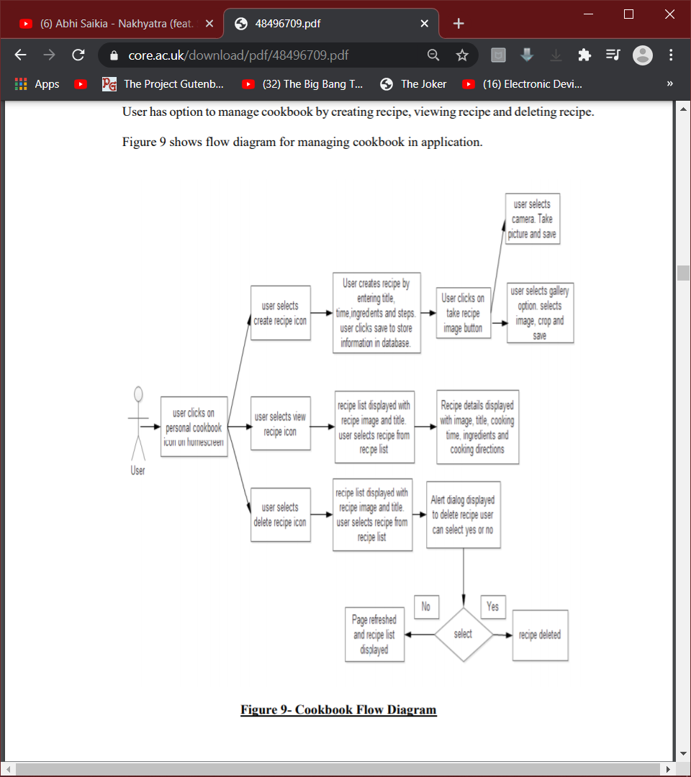

The following block diagram shows the step by step process that the user can inplement to do a particular activity.

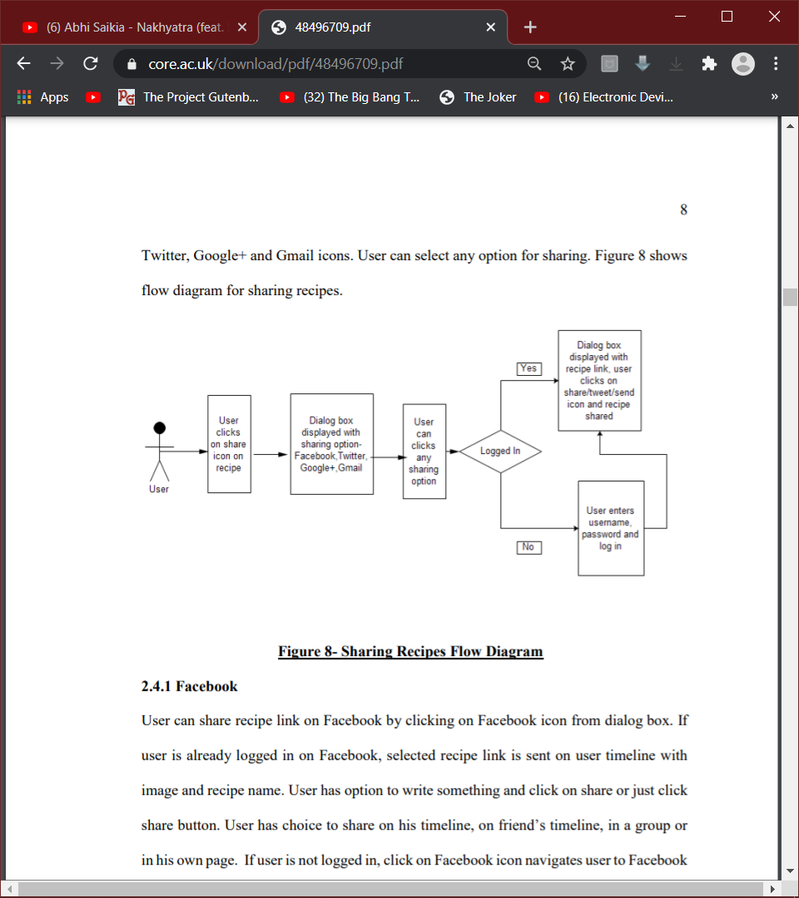

The following diagram shows the other step that user can take i.e to share a particual recipe on social media .Various social media platform such as facebook,gmail,twitter aanad whatsapp are supported.

User can share recipe link on Facebook,Whatsapp,twitter by clicking on the respective icon from dialog box. If user is already logged in on the respective website or application, selected recipe link is sent on user page with image and recipe name. If user is not logged in, click on the icon navigates user to the social sites log in page before user can share .

**4. TENTATIVE CHAPTER PLAN FOR THE PROPOSED WORK**

Android is a Linux based operating system designed primarily for mobile touch.devices such as Smartphones and tablet computers. To make things easier for developers.Google has created Android as an open source and is releasing code under Apache License. Android has a large community of developers who write apps ("apps") that extend the functionality of the devices, written mainly in a custom version of Java

Planning language :-

The QuickRecipes application is written in Java programming language using the SQLite database.

1.The QuickRecipes App code is compiled using the Android SDK tools into a android package, a archive file with .apk annex. This .apk file is considered a single application and is used to install the app on all Android devices like tablets and phones .

There are four different types of application components: activities, services, broadcast receivers and content providers.

4.1 Application Home Page - When user opens QuickRecipes application, application home page as is displayed. User can perform any available option from application home page. The user can search recipes by clicking on categories, top rated, trending, ingredients and search image button. User can view recipes added as favorite by clicking on image button with star on home screen. User can also manage cookbook by creating new recipe, deleting recipe from personal cookbook icon from home screen.

The user will be able to navigate all the options through the home page by clicking on the reespective icon.

**REFERENCES**

[1] Android Developer guide, from http://developer.android.com/ , accessed in March 2015

[2] Android Tutorial, from

http://www.tutorialspoint.com/android/, accessed in March 2015

76

[3] Android Activity Lifecycle Diagram, from http://www.javatpoint.com/images/androidimages/Android-Activity-Lifecycle.png , accessed in April 2015

[4] Android Service Lifecycle Diagram, from http://www.tutorialspoint.com/android/images/android_service_lifecycle.jpg , accessed in April 2015

[5] Android Tutorial, from http://www.vogella.com/tutorials/AndroidBroadcastReceiver/article.html , accessed in March 2015

[6] Marko Gargenta. Learning Android, O’Reilly Media, Inc, March 2011. http://aiti.mit.edu/media/programs/indonesia-summer-2013/materials/gargenta_-_

2011_-_learning_android.pdf , accessed in March 2015 [7] Android Developers Blog, from

http://android-developers.blogspot.com/ , accessed in March 2015 [8] Food2Fork , from

http://food2fork.com/ , accessed in March 2015

1. **APPENDICES**

This is a very handy and useful app to cook a variety of recipe with minimal search effort from the internet. An Internet recipe can be appealing to one but not the other, some people like to try and experiment with their own recipe. This app also gives the user the ability to create a recipe and save it for later use. It will help people save their time and energy in finding daily recipes and special occasions. And since this is a mobile app, users have the luxury of exploring recipes wherever they are and keeping them for the future. The app can be used with a wide range of users that can include parents trying to cook a new recipe for children, people who love desserts, restaurant owner trying to add something new to their menu and regular cooking. It will help make people's lives easier.